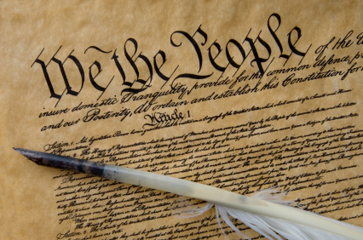
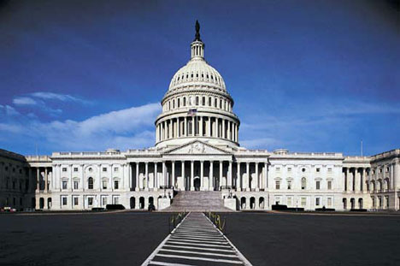

Constitution Exploration!

How does our government work?

You and your partner will create a powerpoint presentation to present the information from your research. It must include a minimum of 4 slides, and must include at least 5 pictures related to the United States government.

Who Makes Up Our Government?
1) List the 3 branches of government, and the jobs of each branch. Type the information into the graphic organizer.

Use the following link: Branches of Government

Extra! Extra!
You and your partner will choose 3 titles of news articles from the links below.
You must: 1) Copy and paste the title of the article onto a slide
2) Decide which branch of government the titles of the articles relate to.

Use the following link: Constitution News Wire

Town Hall Meeting
You and your partner will choose a topic of your choice. You and your partner must:
1) Choose a topic that interests you both. Read the poster.
2) Choose a side, and type a paragraph explaining why you chose that side (use the facts listed on the poster to help you).
3) Decide which branch of government the topic is related to. Include this in the paragraph.

Use the following link: Town Hall Walls Posters

